FOOD WARMER
CART
(With 2 Tier Heated Gantry)

INSTRUCTION MANUAL
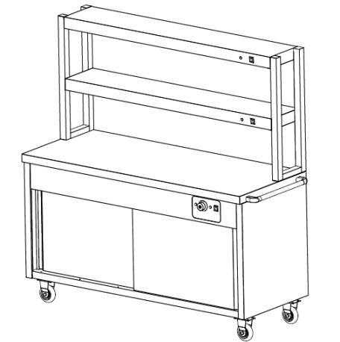

Please read this instruction manual carefully before operation

MAIN TECHNICAL PARAMETERS

MODEL | HYH09HD | HYH12HD | HYH15HD | HYH18HD
DIMENSION | 900*600*860(+700)MM | 1200*600*860(+700)MM | 1500*600*860(+700)MM | 1800*600*860(+700)MM
TEMPERATURE | 30~110°C | 30~110°C | 30~110°C | 30~110°C
POWER | 0.65+0.6+0.6 kW | 0.95+0.9+0.9 kW | 1.25+1.2+1.2 kW | 1.55+1.5+1.5 kW
VOL/FRE | 220 V / 50 Hz | 220 V / 50 Hz | 220 V / 50 Hz | 220 V / 50 Hz
FEATURES
Food warmer carts are used to keep food warm and ready to serve via a heated gantry. Here are some key features you can find on our unit:
• Designed with a dry heated base system and a 2 tier overhead gantry that incorporates additional top-down heating and even heat distribution.
• Insulated compartments and shelves within the cart.
• Independent temperature control that allows users to adjust the heat settings to suit different types of food, enhancing both versatility and efficiency.

• Constructed with a stainless-steel frame for durability, ease of cleaning, and resistance to corrosion.
• Compatible with GN pans of various sizes, it accommodates different food quantities, making it suitable for buffets, restaurants, and catering setups
• Safety features such as overheat protection and lockable castors to ensure stability and reliable operation.
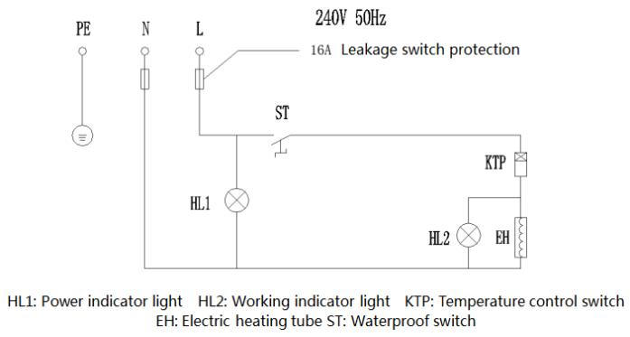
• A simple plug-and-play operation, no complex installation requi

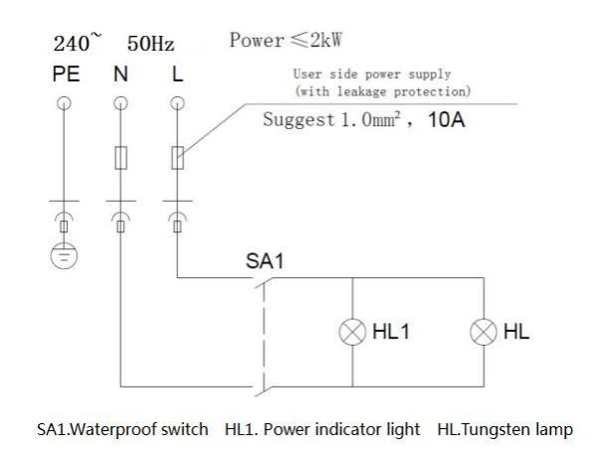


SAFETY PRECAUTIONS AND WARNINGS
READ THIS INSTRUCTION MANUAL BEFORE USING THIS DEVICE AND KEEP DOCUMENT AVAILABLE AT ALL TIMES.
All the information and instructions in this manual take into account standard safety
regulations, current levels of technical engineering as well as the expertise and experience we have developed over the years.
If the delivery consists of a special model, the actual scope of delivery may differ from the
descriptions and illustrations in this manual. This is also the case for special orders or when the device has been modified in line with new technology. Should you have any questions, please contact the manufacturer.
For safety purpose and efficient operation, please read the manual carefully before any operation to the appliance, especially when starting up the device. Install the machine in accordance with this manual and the local related rules.
Please note that this manual is not applicable for those who have physiological, perceptual or psychological barriers or disability, as well as those who are lack necessary knowledge or experience, including children.

NOTICE! Read the instruction manual carefully before using the device. The manufacturer does not accept liability for any damage or malfunction resulting from not following the
instructions for use.
We reserve the right to make technical changes for purposes of developing and improving the useful properties.
WARNING!
ANY REFITTING AND WRONG INSTALLATION, ADJUSTMENT AND
MAINTENANCE CAN LEAD TO PROPERTY LOSS AND CASUALTY. PLEASE
CONTACT THE SUPPLIER IF YOU NEED TO AJDUST OR MAINTAIN IT
AND ALL THESE SHOULD BE CARRIED OUT BY AUTHORISED
PROFESSIONALS ONLY.

WARNING!
DO NOT PUT FLAMMABLE LIQUID, GAS OR OTHER OBJECTS IN OR
AROUND THE PRODUCT TO ENSURE SAFETY.

TRANSPORTATION AND STORAGE
When transporting the food warmer cart, it is important to follow certain guidelines to ensure
safety, equipment longevity, and proper hygiene. Ensure the following guidelines are adhered to during storage:

• DO NOT store outdoors or expose it to the elements. Extreme cold can cause metal to become brittle, and excessive heat can damage electrical components.
• Store in a well-ventilated area. Avoid environments with corrosive gases.
• Always keep the unit upright; do not place it upside down to maintain the integrity of the internal components and ensure proper function when it is in use again.
• Due to the heavy and delicate nature of the heating elements, ensure the unit is handled carefully, especially during loading and unloading.
• Do not place heavy objects on top of the unit, especially on the gantry to prevent damage.
• Use a dust cover or protective wrap to keep the unit clean and free from debris.
• If stored for an extended period, inspect the unit periodically to ensure it remains in good condition, free from pests, mold, or moisture. Also, check the power cord for any signs of wear or damage.
• Lock castors begore loading and unloading the cart. Ensure this is secured with
straps to prevent movement during transit. Use shock-absorbing materials where
possible and avoid bumpy or uneven surfaces to prevent misalignment of shelves or gantry.

INSTALLATION INSTRUCTIONS
1. Carefully remove the unit from its packaging. Inspect for any visible damage. If
damaged, do not use and contact the supplier. Ensure all components, including the heated gantry, power cord, and accessories, are included. These will be flat packed separately.
2. Place the cart on a stable, flat surface to prevent tipping and lock the castors to keep in place. Keep away from flammable materials, water sources, and plastic surfaces.

3. Attach the heated gantry to the base and tighten all screws and brackets securely to prevent instability.

4. Do not install the unit in areas where it may be exposed to excess moisture, such as near sinks or dishwashing areas. Electrical components can be damaged by water, leading to electrical hazards. Choose a well-ventilated location to allow heat to
dissipate, preventing the unit from overheating and ensuring proper airflow around the heating elements.

5. Ensure each separate power supply for the unit is plugged into a dedicated outlet to prevent electrical overload. The unit’s operating voltage must match the supplied
voltage before installation. The unit must be connected to a properly grounded power source to prevent electrical shock or malfunction.

6. Install the unit in a location where it can be easily accessed for daily cleaning and general maintenance. Proper cleaning is critical to food safety and the longevity of the equipment.

7. Make sure the power cords are securely connected and not hanging loosely, which could be a trip hazard.

8. Check the thermostats are functioning correctly, and that the unit reaches required
temperature evenly. Check the indicator light is on operating temperature is reached.

Set the heat control to your desired temperature. Allow the unit to run for several minutes and check if it heats up correctly. Check for unusual smells, noises, or malfunctions before placing food inside.
NOTICE!
This equipment must only be operated by trained professionals or experienced cooks.
• Be cautious of electric shock hazards. Water can conduct electricity, and any electrical leakage may cause accidental shock.
• DO NOT connect the unit to a power supply with a voltage different from the specified requirements.
• Ensure that the main power switch complies with safety regulations before use.
OPERATIONAL USE
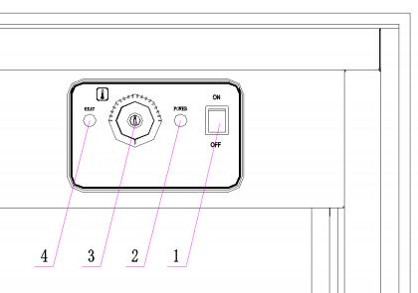
1) Main Switch. 2) Power Indicator Light. 3) Temperature Controller. 4) Heating Indicator Light.
1. Power On and Set Temperature
Once unit has been positioned correctly, before powering the unit on, check switches are set to off and the thermostat is positioned at 0.
Once checked, connect the unit to the power supply, then turn on the power using switches located at the front of the unit.
2. Set Temperature
Adjust the thermostat and set the temperature to the recommended level, to keep the food warm without overcooking or drying it out. If using, ensure the overhead gantry lights are switched on, and check that it is providing even heat distribution from
above.
Allow the unit to preheat for several minutes (usually 5-10 minutes) until it reaches
the desired temperature. The indicator light will turn off when the unit is ready for use. The unit will then automatically go into constant temperature state.
3. Placing Food on the Unit

Place pre-cooked food on the top of the cart, as this unit is designed for holding
temperature, not cooking. Make sure the dishware is clean to avoid excess oils and food debris on the gantry surface. Avoid overloading the unit, as overcrowding can prevent proper heat circulation, leading to uneven warming.
4. Closing down
Once you are finished with the unit, ensure the thermostat is repositioned to 0, and the lights are switched OFF, and then turn the power to the unit OFF.
Additional Tips for Safe Use:
• DO NOT touch the heating element during use in case of scalding.
• Always monitor the temperature to avoid overcooking the food, but also that it maintains a safe serving level.
• The unit will have a hot surface, especially near the heating elements or around the heat lamps. Always use gloves or a cloth when handling trays or parts close to the heat source.
• Keep the unit away from water sources, as water encountering hot oil or electrical components can cause malfunctions or safety hazards.
CLEANING AND MAINTENANCE
1. Disconnect Power Before Cleaning
Always cut off the power supply before beginning any cleaning to prevent accidents or electrical hazards. Allow the unit to cool down completely before cleaning or
moving it.
2. Proper Cleaning Methods
Use a damp, non-corrosive cloth with warm water and a mild detergent to wipe down the exterior surface and the power cord. Never use excessive water or spray the unit directly, as this could damage its electrical components and affect its functionality.
3. Power Off When Not in Use
When the unit is not in use, ensure the thermostat, lights, and the main power switch are turned off to conserve energy and prevent unnecessary wear.
4. Long-Term Storage
If the unit will not be used for an extended period, clean it thoroughly and store it in a
well-ventilated area that is free of corrosive gases. This helps maintain the equipment’s longevity and prevents damage while in storage.
NOTICE!
• DO NOT attempt to replace any parts yourself. All repairs or servicing must be carried out by a qualified technician.
• If the power cord is damag0ed, contact the manufacturer, service department, or a licensed professional for replacement to avoid potential hazards.

DAILY CHECKS
Performing daily checks on an electric food warmer cart is crucial for ensuring safety, operational efficiency, and maintaining food quality. Below are the recommended daily checks you should conduct before, during, and after use:
BEFORE USING | Is the machine tilted or on a solid, stable surface? Is this surface heat-resistant?
BEFORE USING | Confirm that the main power switch is functioning correctly.
BEFORE USING | Verify that all control knobs are in the OFF position before plugging in.
BEFORE USING | Are the power cords old, broken or damaged? Look for any frays, cuts, or exposed wires in the  power cord. Ensure they’re not kinked or pinched.
BEFORE USING | Verify that the unit is clean, with no residual oil, grease, or food debris from previous use.
BEFORE USING | Check that the gantry is securely attached and positioned correctly.
BEFORE USING | Ensure the unit has proper clearance from walls  or flammable objects as specified in the installation instructions.
DURING USE | Turn the unit on and allow it to preheat. Observe whether the heating elements or heat lamps are functioning properly.
DURING USE | Periodically check the thermostat to ensure that  the temperature remains within the desired range. If the temperature fluctuates, adjust it accordingly.
DURING USE | Ensure the heated lamps continue to stay on and provide even heat distribution without flickering.

TROUBLESHOOTING
This table covers common operational issues and provides straightforward solutions to help troubleshoot problems effectively.
 | Ensure food is evenly placed for proper heat distribution.
Watch for any burning smells or smoke, which
could indicate an issue with the heating element or oil burning.
 | Ensure the unit is operating without unusual noises or odours.
AFTER USING | Turn the unit off and unplug from the power sources and allow the unit to cool before  cleaning.
AFTER USING | Inspect the heating elements or heat lamps for any signs of wear, discoloration, or damage.
AFTER USING | Clean the unit’s exterior and power cords to remove any grease or food splatter.
AFTER USING | Wipe down the unit’s interior, including  removeable parts with a non-corrosive, damp cloth.
AFTER USING | Make sure the unit is completely clean and dry,  with no lingering grease or food residue that could attract pests or lead to hygiene issues.
AFTER USING | Confirm that the ventilation remains free of  obstructions after use to maintain airflow and prevent overheating.
AFTER USING | If storing the unit for the night or for an extended period, cover it with a dust cover or plastic wrap to keep it free from debris or dust.

ISSUE | POSSIBLE CAUSE | SOLUTION
Unit does not turn on | - Not plugged in properly | - Ensure the unit is  plugged into a properly grounded outlet.
Unit does not turn on | - Faulty power outlet or tripped breaker | - Test the outlet with another device.
Unit does not turn on | - Blown fuse or tripped circuit breaker | - Reset the circuit breaker or replace the fuse
Unit does not turn on | - Damaged power cord | - Inspect the power cords and replace if damaged.
Unit does not turn on | - Internal wiring issue | - Contact a technician to inspect the internal fuse.
Base or gantry does not heat up | - Thermostat is set too low | - Increase the temperature setting on the thermostat.
Base or gantry does not heat up | - Heating element malfunction | - Check if the heating element is damaged; contact a technician.
Base or gantry does not heat up | - Electrical connection issue | - Ensure power cord is properly connected, and outlet is functional.
Base or gantry does not heat up | - Heating elements are dirty or faulty | - Clean or replace heating elements  - Ensure vents are not blocked

 | - Blown internal fuse | - Have a qualified  technician inspect and replace the fuse.
Uneven heating | - Food not evenly distributed | - Stir or spread the food more evenly across the tray.
Uneven heating | - Heat lamp malfunction | - Check if the heat lamp is functioning and replace if necessary.
Uneven heating | - Overloading the unit | - Avoid overloading the unit; keep the amount manageable.
Unit overheating or too hot | - Thermostat malfunction | - Test and recalibrate the thermostat if possible.  Contact a technician if necessary.
Unit overheating or too hot | - Faulty temperature sensor | - Check and replace the thermostat or sensor if needed.
Wheels are not rolling properly | - Dirt or debris stuck in wheels | - Clean and lubricate the wheels
Wheels are not rolling properly | - Wheels are loose or damaged | - Tighten screws or  replace damaged wheels
Electrical smell or smoke | - Debris or grease buildup on heating elements | - Turn off and unplug immediately
Electrical smell or smoke | - Electrical short circuit | - Clean any grease or debris from the unit
Electrical smell or smoke | - Overheated components | - Contact a technician if the problem persists
Unit trips the circuit breaker | - Overloaded circuit | - Use a dedicated power outlet
Unit trips the circuit breaker | - Short circuit in the warmer | - Inspect for damaged  wires and get professional servicing
Unit trips the circuit breaker | - Faulty power cord | - Avoid using extension cords or overloaded  sockets

DISPOSAL OF OLD MACHINE
When your electric food warmer cart reaches the end of its useful life, it must be
disposed of in an environmentally responsible manner. Follow these steps for proper disposal:
1. Disconnect from Power Supply
Ensure the unit is completely disconnected from the power supply. Remove the plug from the outlet and, if necessary, cut the power cord to prevent accidental reuse.
2. Consult Local Regulations
Check your local regulations regarding the disposal of electrical appliances. Most regions have specific guidelines or designated facilities for recycling or safely
disposing of electric equipment to minimise environmental impact.
3. Recycling
Many components of the unit, such as metal parts, wiring, and certain electronic components, can be recycled. Contact a certified e-waste recycling centre or your
local waste management facility to ensure the unit is properly dismantled and recycled.
4. Hazardous Materials
The unit may contain electronic components or other materials (such as insulation) that could be hazardous if not disposed of correctly. Ensure these parts are handled by a professional or through an authorized recycling program.
5. Avoid Landfills
Do not dispose of the unit in general household waste or send it to a landfill.
Improper disposal can contribute to environmental pollution, as certain materials may not decompose and could release harmful substances.
WARRANTY
KRD CATERING EQUIPMENTS LTD Ltd warrants the original purchaser of every new product (under normal and proper use and maintenance service as specified by Adexa Ltd and upon proper
installation and start up in accordance with the instruction packet supplied with each unit) a one-year parts warranty.
obligation under this warranty is limited to a period of one (1) year from the date of original installation.
The warranty is applicable to parts only and does not cover labour or servicing costs associated with the replacement or repair of defective parts.
The manufacturer shall not be liable for any incidental or consequential damages arising from the use of the product, including but not limited to loss of use, loss of time, or any
other losses incurred.
WARRANTY CLAIMS:
All claims for parts must be made directly through the retailer in the first instance. All claims raised with the retailer should include:
• Your name
• Your company
• Model number
• Serial number of the product
• Delivery address
• Date of purchase
• Email
• Proof of purchase
• Phone number

• Information supporting the alleged defect/failure (video/photo)
• Photo of the dataplate

EXCLUSIONS!
This warranty does not cover:
• Damage caused by misuse, neglect, accidents, or unauthorised repairs.
• Normal wear and tear, including but not limited to cosmetic damage, scratches, or dents.
• Damage caused by external factors such as fire, water, or natural disasters.
• Any parts or accessories not included in the original purchase.
• Bulbs are not covered under warranty.

